TEST 5

create a SSIS package that display audit log   
create a SSIS Package that display error handling   
create a SSIS package that display Fuzzy Grouping   
create a SSIS package that display term extraction

1. create a SSIS package that display audit log

Ans:

Execution in SSIS:

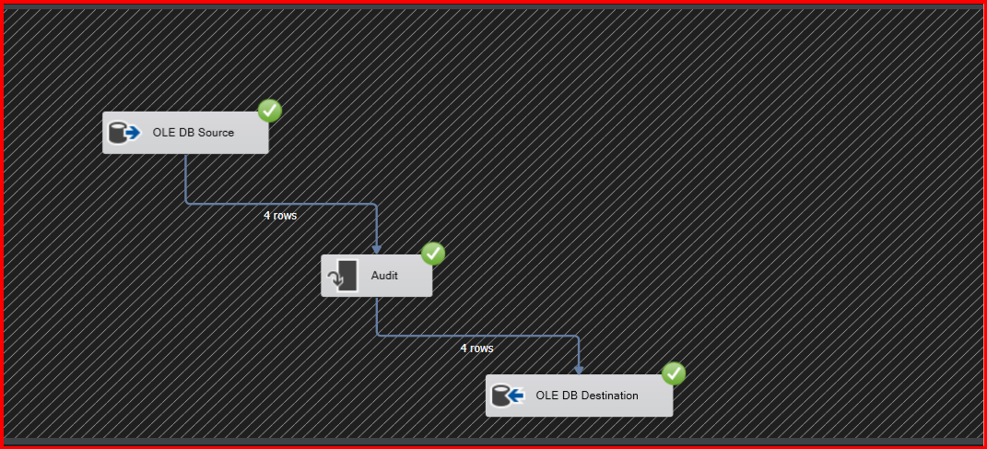

Execution in SSMS: 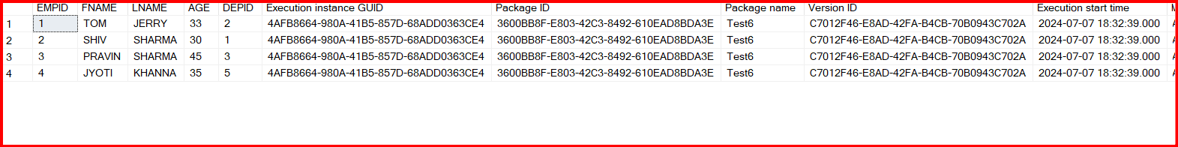

1. create a SSIS Package that display error handling

Ans:

Flat file source input:

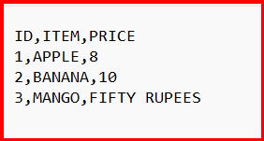

Execution in SSIS:

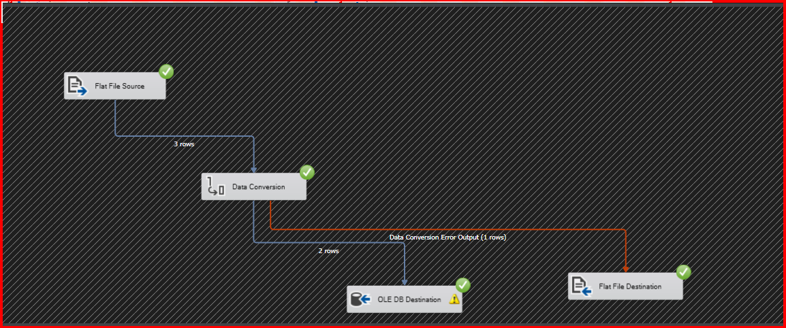

Create table script:

CREATE TABLE RATE

(

ID INT,

ITEM VARCHAR(35),

PRICE MONEY)

Execution in SSMS:

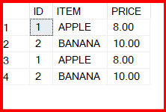

1. create a SSIS package that display Fuzzy Grouping

Ans:

Flat file Source input:

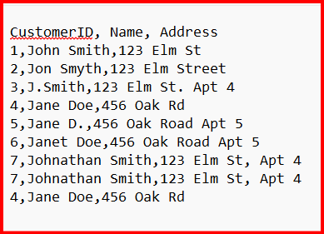

Execution:

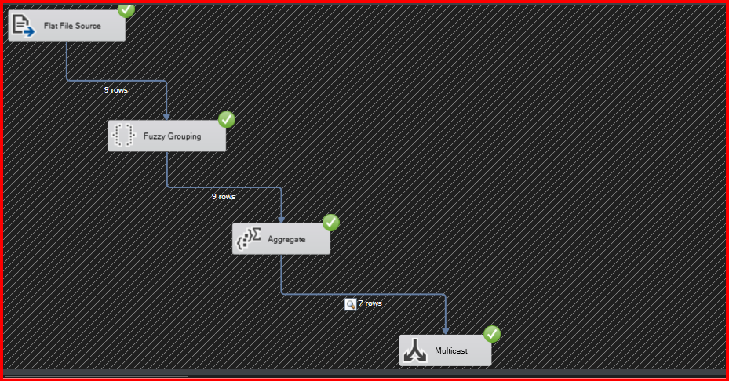

Output:

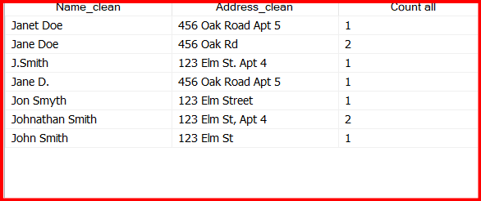

1. create a SSIS package that display term extraction

Ans:

Source table in OLEDB Souce:

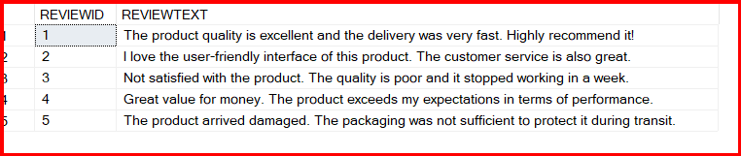

Execution in SSIS :

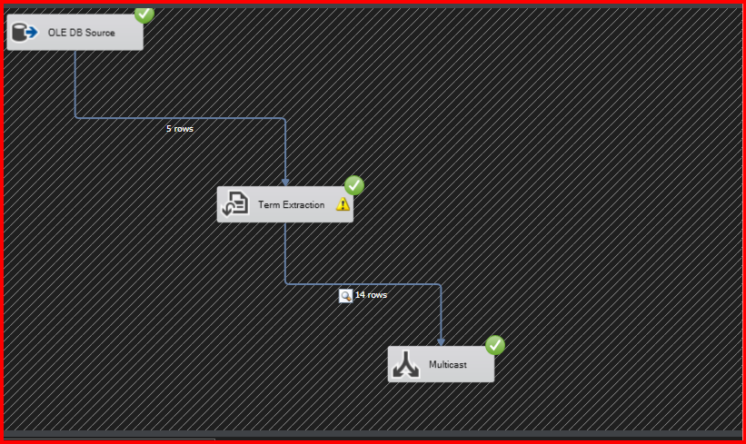

Output:

